CSIS3275-003 Software Engineering Project

# Sport Betting Analysis Website:

# GameDayTrades.com (GDT)

Team Awesome

Group Members:

Edison CHAN (300370372) - WCEdison

Catherine Methven (300361000) - camm9

~~Jaimin Shah (300353635) -jaik27~~

Washington Valencia (300366206) - educristo777

## GitHub Repo:

<https://github.com/camm9/GroupAwesomeProjectProposal.git> [origin/release_v2_oauth]

## Important!!!

1. Current Branch for release **[origin/release_v2_oauth]**
2. Important change in user story and project schedule because of team drop out
3. Meeting Notes updated with meeting 3 and 4

# 1.Project Scope

1. Our product is a sports betting analytic website, in short, *“use the modern ux from finance website and stocks analytics website, but for football and other sports”*
2. The target audiences are the people who are betting in sports, or simply want a prediction and forecast for their favourite team before each match.
3. The problem we are solving is that the UX for the sport betting website doesn’t have the in-depth and intuitive analytics like timeline, trends, statistics comparison, analytics tools that stock market websites possess.
4. There are existing sports betting website like Playnow, Sportsbook, Betway
5. Our System will be different because we will be more dataset focused, and present data like a stock market analysis including historical performance and trend

## 1.1 Solution and Problem:

Fig 1.1 Playnow on Football Statistics

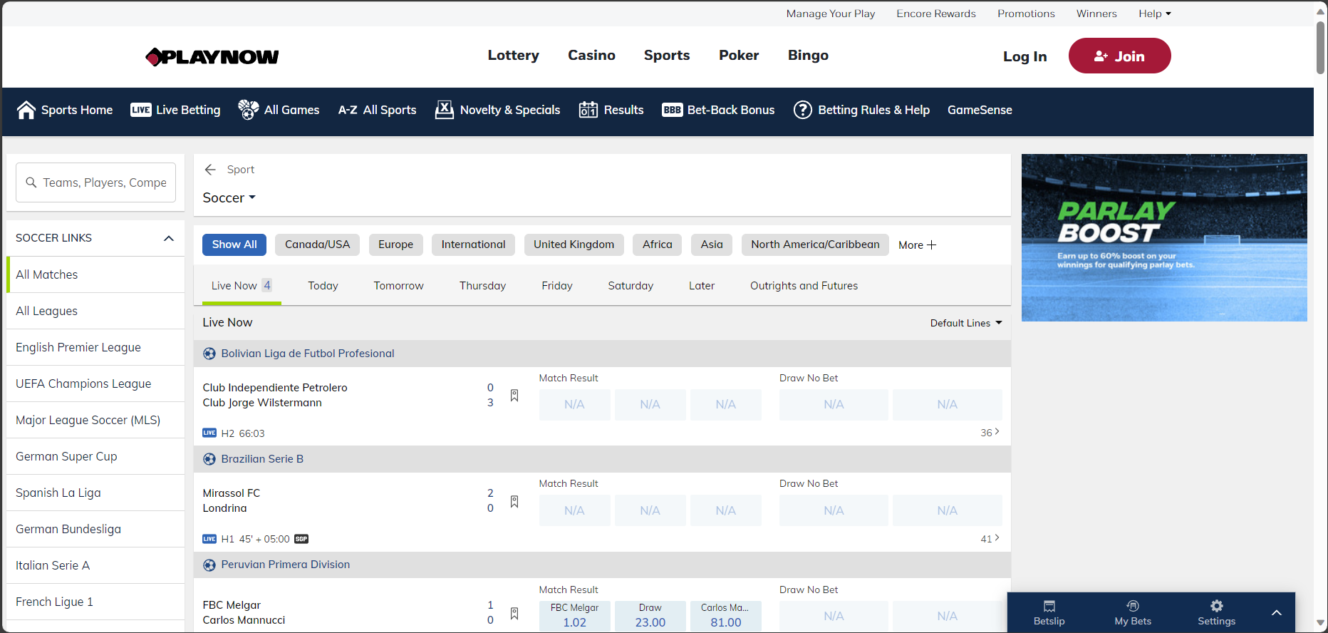

Fig 1.2 Sportsbook on Football Statistics

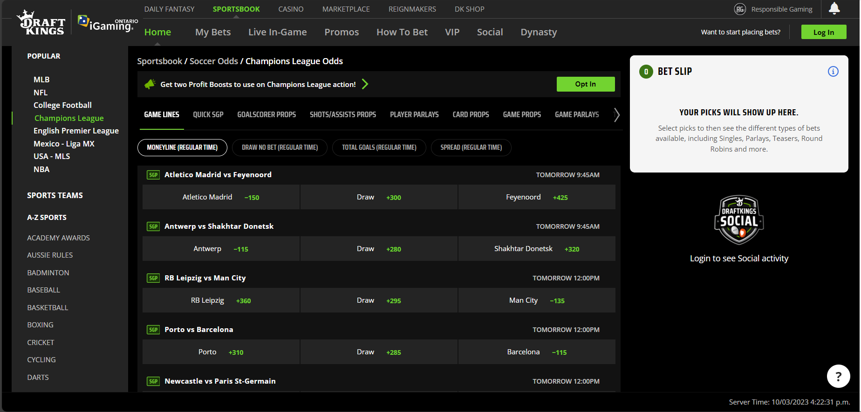

Fig 1.3 Betway on Football Statistics

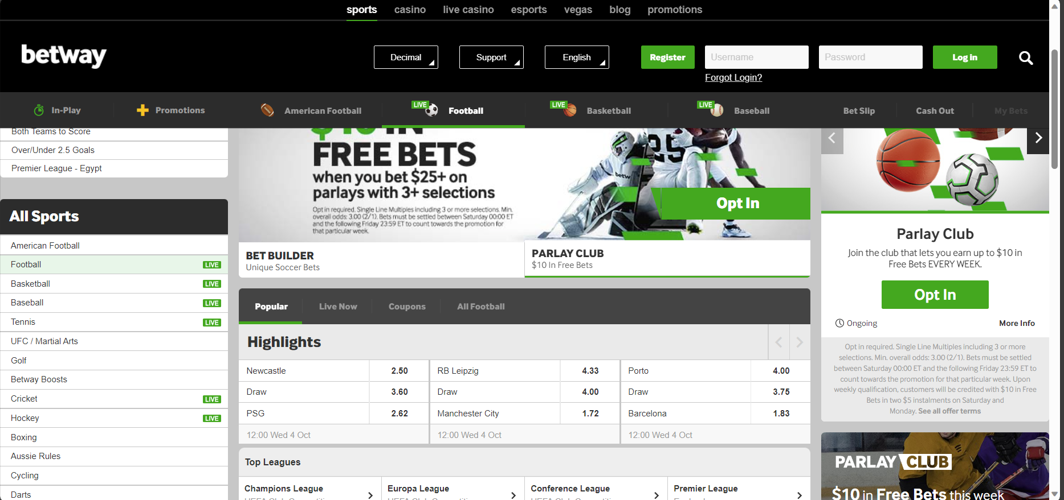

In Fig 1.1, 1.2 and 1.3, we show how typical sport websites present their data, while we wish to introduce concepts from finance websites like Fig 2.1, Fig 2.2 and Fig 2.3, with forecast, past record, trend, ROI and lastly saving the (investment/betting) profile.

Fig 2.1 FXStreet Analysis

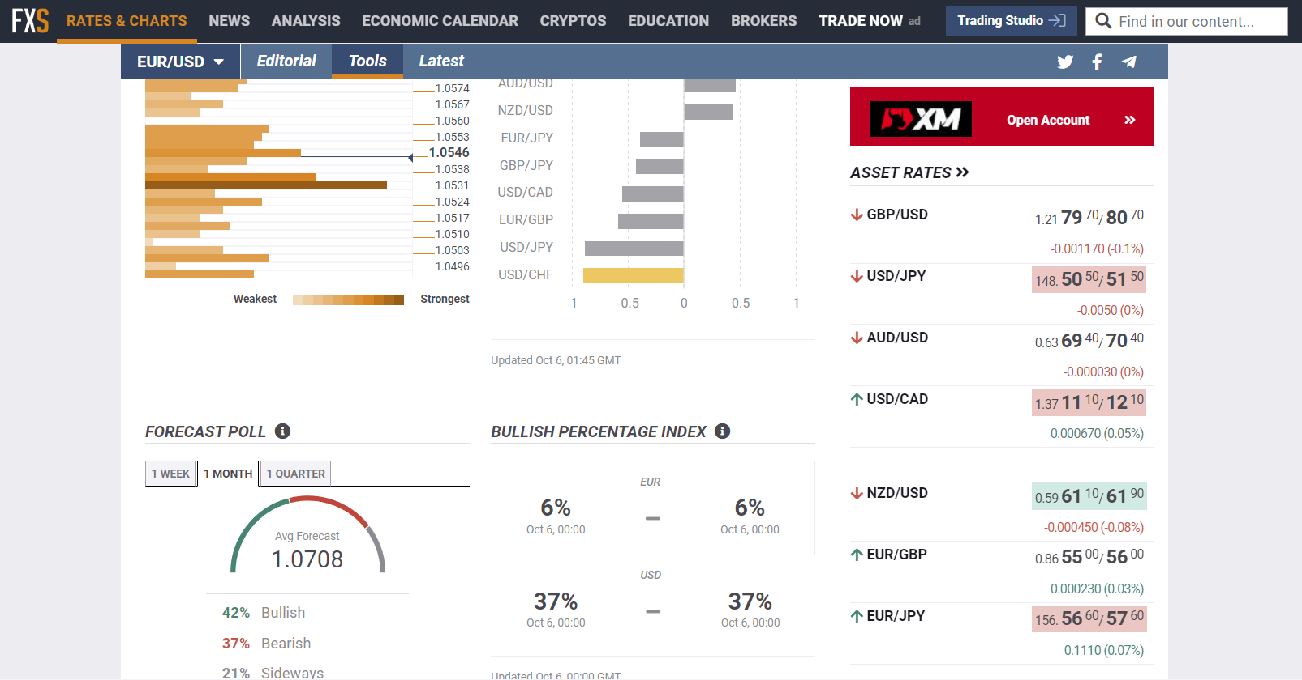

Fig 2.2 Yahoo Finance

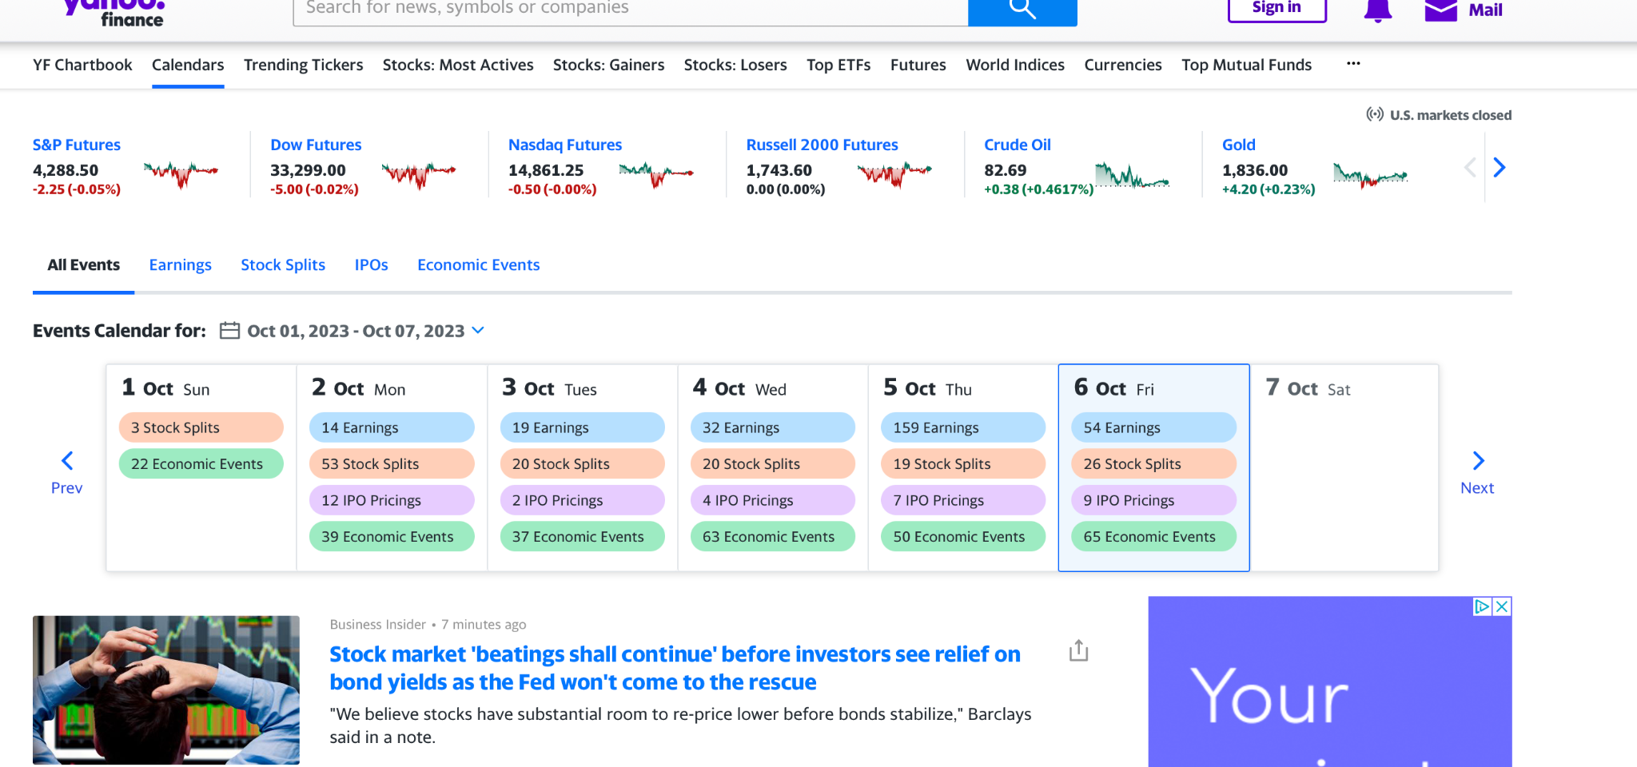

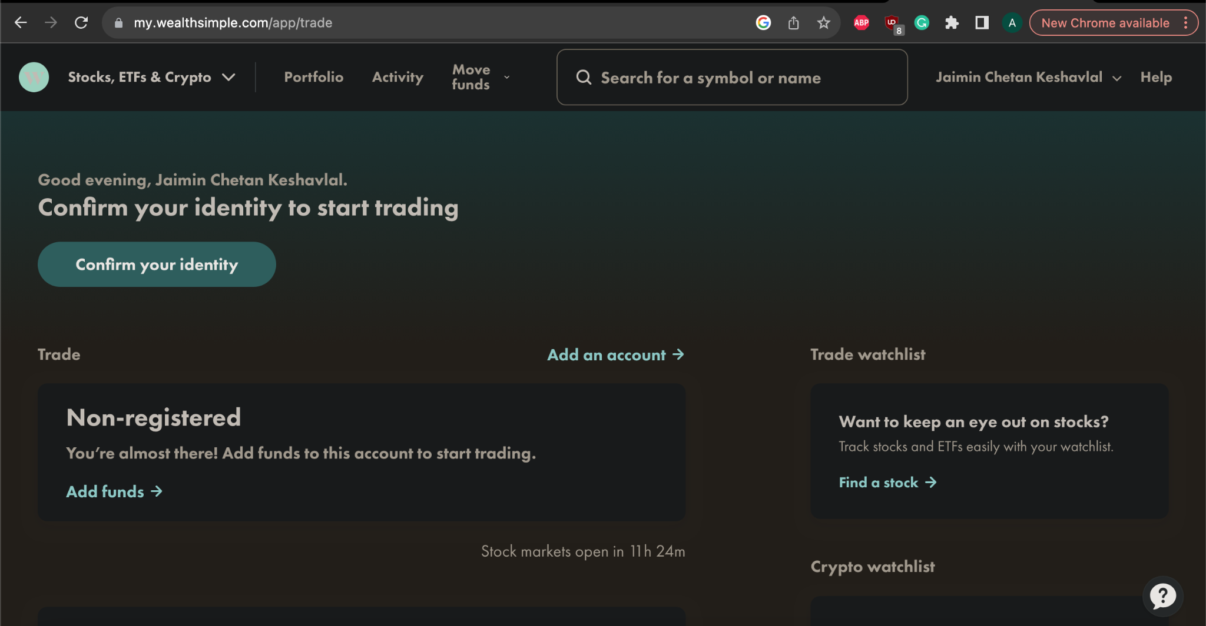

## 1.2 User Stories

|  |  |
| --- | --- |
| ***Story*** | ***Description*** |
| As a **site visitor**, I want to create an account and log in so I can have a personalised data | To interact with flexibility, comfort and total control visitors will be able to sign up and meet their thrills and requirements with custom datasets. |
| As a **site visitor**, I want to search for sports betting statistical data so I can bet wisely | Visitors will be able to review and filter news, trends, etc., quickly and with simple clicks in order to stay up to date with all betting scenarios. |
| As a **site visitor**, I want the latest football news headlines so I can stay up-to-date with all betting scenarios |
| As a **site visitor**, I want to view live game statistics so I can stay up-to-date while on the site |
| As a **site member**, I want to add save my favourite datasets so I can view them easily and quickly | With easy to use and interactive interfaces, members will be engaged and will meet their thrills and requirements with custom datasets. They will decide the level of risk to deal and compete and you will continually receive notifications that help you take care of your finances and at the same time not miss opportunities. |
| As a **site member**, I want to create custom datasets so I can view them at later dates |
| As a **site member**, I want to export my favourite datasets so that I can share them with friends |
| As a **site member**, I want to notifications for a particular betting odd of my choosing so I never miss out on a good deal |
| As a **site member**, I want see historical performance of past betting odds so I can assess my previous bets | With historical behaviours available, members will combine data with their betting skill and knowledge to make the round more interesting. Filtering options will allow members to access past data quickly and precisely. |
| As a **site member**, I want to see the top performing members so I can see the highest ROI% | With best navigation practices, members will know how to obtain relevant information about members, to place a bet in fractions of a second competing with friends or colleagues. |
| As a **site member**, I want to export my favourite bets to share on social media | To make the sport and betting more interesting, users can easily download their available data to share with friends/colleagues. |
| As **site admin**, I want to be able to Create Rename Update Delete (CRUD)  on users | To manage/maintain the system available,​​managing user profiles, troubleshooting issues, and **proactive user managemet-** user behavior data to gain insights into how users interact with the system. |

## 1.3 Initiatives

Our group project’s user stories can be divided into 3 different epics that address the initial creation of a membership website and the building of features that allow members to analyse their favourite sports betting statistics. These epics can summarised as the following and assigned to the first three sprints of the project:

|  |  |  |
| --- | --- | --- |
| ***Sprint #*** | ***Initiative*** | ***Epic*** |
| Sprint 1 | Database, landing page and basic data search | Create website that retrieves popular football betting statistics |
| Sprint 2 | Save and customise various data feed | Add personalised betting statistic selection and file export |
| Sprint 3 | Re-imagine the Online Sports Betting UX Model | Add features (historical trends, relevant news feed, user notifications, betting predictions, performance metrics, custom betting strategies) and improve file export and sharing |

Based on the initiative and epic descriptions of the project, we have created what we predict to be the major user stories of the first three sprints in the table below. However, it is important to note that as the project progresses user stories may be changed as issues arise and are added to the project backlog.

## 1.4 Entities

Our stories will focus on the most important entities which are:

1. **site members,**
2. **site visitors (not members yet),**
3. **site admins**, and
4. **b2b data provider**, e.g. bet365.

## 1.5 External Components

This webpage will be using **web services**,

1. Oauth2 to login,
2. social media api to share profile,
3. some examples of statistical APIs we will use are Football xG Statistics and Football Betting Odds found on RapidAPI;

We use the **file system** to export betting profiles or import past profiles to be shared.

1.6 Software Tools

Our group has agreed on the following tools to aid in the completion of the project:

* JavaScript, HTML and CSS, Java
* Eclipse IDE - as our coding editor
* Git - for source control management
* Source Tree - provides visualisation of Git for source control management

# 2. Project Schedule

|  |  |  |  |
| --- | --- | --- | --- |
| ***Sprint #*** | ***Story*** | ***Team Member*** | ***Points*** |
| 1 | 1.1 As a site visitor, I want to create an account and log in so I can have a personalised data (login) | Edison | 4 |
| 1 | 1.2 As a site visitor, I want to search for sports betting statistical data so I can bet wisely (search) | Catherine | 2 |
| 1 | 1.3 As site admin, I want to be able to Create Rename Update Delete (CRUD) users (database) | Washington | 4 |
| 2 | 2.1 As a site member, I want to create custom datasets so I can view them at later dates (custom filter) | Catherine | 2 |
| 2 | 2.2 As a site member, I want to export my favourite datasets so that I can share them with friends (export data) | Edison | 2 |
| 2 | 2.3 As a site visitor, I want to view live game statistics so I can stay up-to-date while on the site (live data feed) | Catherine | 1 |
| 2 | 2.4 As a site visitor, I want the latest football news headlines so I can stay up-to-date with all betting scenarios (news feed) | Edison | 1 |
| 2 | 2.5 As a site member, I want to save my favourite datasets so I can view them easily and quickly (save data) | Jay | 2 |
| 2 | 2.6 (follow up on 1.4) As a site visitor, I want a simple user interface so I can quickly view my preferred datasets (data presentation) | Washington | 2 |
| 3 | 3.1 As a site member, I want to notifications for a particular betting odd of my choosing so I never miss out on a good deal (notification) | Catherine | 2 |
| 3 | 3.2 As a site member, I want see historical performance of past betting odds so I can assess my previous bets (historical performance) | Washington | 3 |
| 3 | 3.3 As a site member, I want to see the top performing members so I can see the highest Return On Investment % (rate of return calculator) | Jay | 3 |
| 3 | 3.4 As a site member, I want to export my favourite bets to share on social media (social media) | Edison | 2 |

## 3. Group Dynamics

1. Clarify who will be your Team Leader in the group,
   1. [Edison CHAN] will be the team leader in this group (Dev/Documentations/PR)
2. What will be the other roles of each member?
   1. Edison [Lead/Dev/Documentations/PR]
   2. Catherine [Dev/Tester]
   3. Washington [Dev/Ops/Designer]
   4. Jamin[Dev/db manager]
3. Were there any disagreements in the roles?
   1. So far we have no disagreement in the roles
4. How were they dealt with?
   1. We will have weekly meeting before the lecture
   2. We will have follow up meeting or coworking session for issue to be solved on Thu/Fri timeslots
   3. We have some basic ground rules
      1. No force pushing to the main/development branch, main branch is protected with 1 person review requirement
      2. We are work in our own branch, one person is in charge of merging the various branch to avoid conflict or untested bug being pushed to development branches
      3. If there is going to be disruption in schedule, we have to alert all other teams members in advances as early as possible
      4. In agile development changes are welcome, but decisions made in meetings should be amended and agreed upon in the next meeting where all members have mutual consensus
      5. All members should be on the same page in all sprints and meetings, if there is uncertainty or changes, please raise them as soon as possible, and it is the obligation for each member to attend meetings and be in-sync with the team

## 4. Meeting Minutes

### 1st Meeting 28 SEP 2023

Attendance: All

What had we done before?

1. Brainstorming,

2. basic schedule checking,

3. project proposal reading

What are the difficulties, which questions are being solved?

1. How do we schedule a weekly meeting time?

Next Meeting (3 Oct 2023 1115) 15 min before lecture

30 minute before Lecture Tuesday 1100

Friday night

Thursday afternoon

2. What is our final topic? How is it going to be implemented?*

Data sources and API needed:Solved, we have <https://rapidapi.com/collection/list-of-free-apis>

[Please note potential issue with https]

21 Free Public APIs for Developers & Free Alternatives List - September, 2023 | RapidAPI

Browse 21+ Free Public APIs for Developers available on RapidAPI.com. Top Free Public APIs for Developers include Google Translate, Movie Database Alternative, API-FOOTBALL and more. Sign up today ...

Webapi: Use the above

File System: Allow user to export data

3. Does it fit the project requirement without going too far to impact our work-life balance?

Exact Scope Undefine - to be done by 30 Sep

4. What are the milestones and objectives for each sprint?

1. Multiple User
2. Export Data
3. Web API Access
4. Suggestions
   1. Notification System
   2. Additional Sports

5. What are the job distributions for each sprint (volunteer only, avoid assigning task)?

To be done Sat [Pending]

6. Who is going to edit and submit the final project proposal?

See Actual Proposal document at <https://docs.google.com/document/d/1nW8A950voEpuOKRNZyGm-1PU9WvXRRF9Q7yWqkmcrGs/edit?usp=sharing>

Meeting Minutes

7. Who is going to submit assignment 2?

[From Actual Proposal Requirement]

1. Project Scope
   1. Answer the following questions in this section,
      1. What is your product? *
         1. Football (Sports) betting analytic website
      2. Who is the target audience you expect to use the software and what problem is it solving?
         1. Football fans and betting companies
      3. Are there any similar systems on the market?
         1. Yes, football betting website and record websites
      4. How will yours be different?
         1. It incorporate feature from fiance websites
      5. What are the major user stories in your software?

[Jamin]

* + - 1. User Story 1: As a user, I want to analyse historical sports data to identify trends and patterns.
      2. User Story 2: As a user, I want to receive real-time updates on game scores and statistics.
      3. User Story 3: As a user, I want to access machine learning predictions for upcoming games.
* User Story 1: Access to historical data for analysis and trend identification.
* User Story 2: Real-time updates and scores, crucial for live betting.
* User Story 3: Machine learning predictions, providing valuable insights for upcoming
  1. Provide some brief descriptions of these user stories as well as the value they will add to the customer.

1. Group Dynamics # [Done]

What is to do? When is the next meeting?

1. Assignment 2 (No idea, still not posted yet)

2. Project Proposal [Basic Content by Edison Done by 28 Sep (THU), All Content Done by All on 30 Sep (SAT)]

3. Project Sprint 1 [To be confirm after scope and user story is finalised]

4. Need time for weekly meetings.

Next Meeting 15 min in-sync before the lecture

Possible Long meeting (1hr) on Thu/Fri depending on availability of team

---------------------------------------------------------------------------------------------------------------------------

### 2nd Meeting (1 hr): 1800 5 Oct 2023

Attendance:

All

What had we done before?

1. Completed Assignment 2 web app
2. Finish the majority of user story and design of project
3. Project proposal final draft

What are the difficulties, which questions are being solved?

1. The final draft of project proposal has been worked on
2. The project requirement has been gone through entirely
3. The assignment 2 requirement has been gone through entirely
4. Solved issue with solution not specific enough for project design
5. Solved

What is to do? When is the next meeting?

1. Upload the project proposal
2. FInish our own review question on
3. Double check task assignment on assignment 2 on github project
4. Push the dev branch to release

---------------------------------------------------------------------------------------------------------------------------

### 3rd Meeting (1hr) 19 Oct 2023 (1hr 1200)

Ech

What had been done before?

1. Register for Oauth2 for Github, check procedure to register for Google Oauth2 for a educational project
2. Research for spring implementation for Oauth2, including how token is parse and stored
3. Coordinate for class diagram, ERD and flowchart, check with Jaimin for possible database design

Estimated Completion:

20% As of meeting (Thu)

80% By Sat

100% By Sun

What are the difficulties, which questions are being solved?

1. The current html template and some sample class still follow the typical user-email-password method, which should be switched to UserId - token architecture
2. Logistics issue: Editing ERD on draw.io appears to be difficult on Github, maybe generate and co-edit the draw.io diagram at google and export it to Github, we also lack a routine to keep updating the document and design draft to github
3. We need exact example for data storage, need to confirm with Washington and Catherine that the design (1) fit our current webpage data requirement (e.g. filter, paid user, admin), and (2) has corresponding ui that can update/edit/access the data

What is to do? When is the next meeting?

1. Add Oauth2 for Github and Google (optional?) to the system on Sat
2. Test if user can login with GitHub account as admin/user
3. Display minor UI changes for Admin and User → Washington & Jamin, do we need an admin control ui?

Cat

What had been done before?

1. Called API successfully,

What are the difficulties, which questions are being solved?

Errors with Object Mapper when attempting to turn JSON into Java object.



What is to do? When is the next meeting?

1. Fix Object Mapper Error (Catherine)

Jam

What had been done before?



Completion

100% Mon

What are the difficulties, which questions are being solved?

What is to do? When is the next meeting?

**Washington**

What had been done before?

1. Bootstrap framework analysis.
2. Landing page.
3. Login page.

Completion

100% Thu

What are the difficulties, which questions are being solved?

1. Link html pages with JS, an open-source JavaScript library for data visualization.
2. Hiding content in order to fit the small screen was a really challenging thing. To show a responsive page first of all I worked to hide content and show them properly according to the mobile device.

What is to do? When is the next meeting?

1. Create a new page in which members can interact with the data from API. In this web page we also need to add options to export and see the latest activity.
2. Implement admin options to edit, delete and add new members with admin role.

---------------------------------------------------------------------------------------------------------------------------

### 4th Meeting (1 hr): 29 Oct 2023 (1hr 1200)

1. Emergency: fix update and implement h2 along with other part of the project for sprint 1

fix update and implement h2 along with other part of the project for sprint 1

1. Implement a simple h2

2. Rearrangement/Re-confirmation of job distribution and user story

3. Sprint 2 execution plan (considering after next lecture, we got quiz 3)

4. Role of all members in the coming sprints to handle unbalanced work distribution/push record

Ech

What had been done before?

1. Oauth 2 Login via Github

What are the difficulties, which questions are being solved?

1. Merging system to a database

What is to do? When is the next meeting?

1. ERD Draft (Tue)
2. Assist Catherine H2/CRUD Implement (Mon Night)

Catherine

What had been done before?

Completed the method to create a table of matches for a given date in YYYY-MM-DD. This can be fed into a HTML table and will display match IDs.

I am now working populating the match objects with the odds for a given match ID. The goal is to be able to feed these into the HTML.

What are the difficulties, which questions are being solved?

* I would like to test feeding into the HTML with a table, I wonder if there is a particular page I should be testing this with?
  + For Sprint 2, we will need to figure how to pass user input for the date to populate the table
* I need to add country, competition (league), match time to table of matches.
* Not sure what the current issue is with populating the Odds. It’s a nested JSON so I’m not sure if the issue is with the JSON call or the constructor.

What is to do? When is the next meeting?

* Figure out how to parse the Odds (child class) into the parent class of Datum.
* Get feedback where I can put a target HTML to populate with match data
* Set up h2 database with CRUD (username, email, password) with a new branch
* Decide on football news API to use (maybe https://rapidapi.com/onlyaddy68/api/football_api12/ )

Jam

What had been done before? 2

Setup CRUD for a mysql Db workflow and integration/validation of frontend (html templates) with backend (controllers & model class)

What are the difficulties, which questions are being solved?

Difficulty/stuck with resolving an issue regarding having eclipse not recognizing model class (User.java) as a JPA entity either due to hibernate / ide issues

What is to do? When is the next meeting?

Decide on what to assist and work on with the next milestones/sprint

**Washington**

What had been done before?

1. Revision

What are the difficulties, which questions are being solved?

1. NA

What is to do? When is the next meeting?

1. Assist Edison and Catherine in CRUD implementation